**Congressional Voting Records Data Set**

1984 United Stated Congressional Voting Records; Classify as Republican or Democrat

**Data Set Information:**

This data set includes votes for each of the U.S. House of Representatives Congressmen on the 16 key votes identified by the CQA. The CQA lists nine different types of votes: voted for, paired for, and announced for (these three simplified to yea), voted against, paired against, and announced against (these three simplified to nay), voted present, voted present to avoid conflict of interest, and did not vote or otherwise make a position known (these three simplified to an unknown disposition).

Attribute Information:

1. Class Name: 2 (democrat, republican)   
2. handicapped-infants: 2 (y,n)   
3. water-project-cost-sharing: 2 (y,n)   
4. adoption-of-the-budget-resolution: 2 (y,n)   
5. physician-fee-freeze: 2 (y,n)   
6. el-salvador-aid: 2 (y,n)   
7. religious-groups-in-schools: 2 (y,n)   
8. anti-satellite-test-ban: 2 (y,n)   
9. aid-to-nicaraguan-contras: 2 (y,n)   
10. mx-missile: 2 (y,n)   
11. immigration: 2 (y,n)   
12. synfuels-corporation-cutback: 2 (y,n)   
13. education-spending: 2 (y,n)   
14. superfund-right-to-sue: 2 (y,n)   
15. crime: 2 (y,n)   
16. duty-free-exports: 2 (y,n)   
17. export-administration-act-south-africa: 2 (y,n)

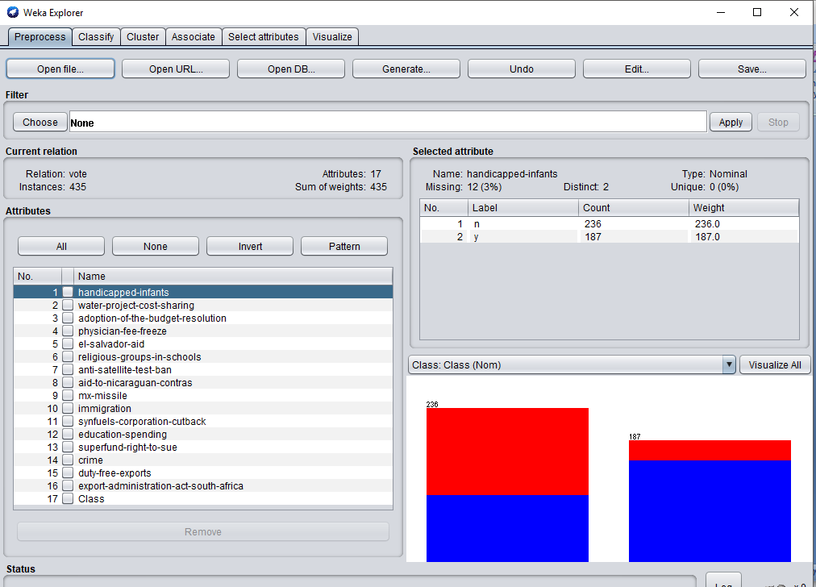

Using **Waikato Environment for Knowledge Analysis** (**Weka**) ,a suite of [machine learning](https://en.wikipedia.org/wiki/Machine_learning) software written in [Java](https://en.wikipedia.org/wiki/Java_(programming_language)), we can represent the dataset Weka contains a collection of visualization tools and algorithms for [data analysis](https://en.wikipedia.org/wiki/Data_analysis) and [predictive modeling](https://en.wikipedia.org/wiki/Predictive_modeling), together with graphical user interfaces for easy access to these functions.

ALGORITHMS USED

C4.5 algorithm

**C4.5** is an algorithm used to generate a [decision tree](https://en.wikipedia.org/wiki/Decision_tree_learning) developed by [Ross Quinlan](https://en.wikipedia.org/wiki/Ross_Quinlan).C4.5 is an extension of Quinlan's earlier [ID3 algorithm](https://en.wikipedia.org/wiki/ID3_algorithm). The decision trees generated by C4.5 can be used for classification, and for this reason, C4.5 is often referred to as a [statistical classifier](https://en.wikipedia.org/wiki/Statistical_classification).

**C4.5 builds decision trees from a set of training data in the same way as** [**ID3**](https://en.wikipedia.org/wiki/ID3_algorithm)**, using the concept of** [**information entropy**](https://en.wikipedia.org/wiki/Entropy_(information_theory))**.**

**At each node of the tree, C4.5 chooses the attribute of the data that most effectively** splits its set of samples into subsets enriched in one class or the other. The splitting criterion is the normalized [information gain](https://en.wikipedia.org/wiki/Information_gain_in_decision_trees) (difference in [entropy](https://en.wikipedia.org/wiki/Entropy_(information_theory))). The attribute with the highest normalized information gain is chosen to make the decision. The C4.5 algorithm then recurs on the smaller sublists.

This algorithm has a few base cases.

* All the samples in the list belong to the same class. When this happens, it simply creates a leaf node for the decision tree saying to choose that class.
* None of the features provide any information gain. In this case, C4.5 creates a decision node higher up the tree using the expected value of the class.
* Instance of previously-unseen class encountered. Again, C4.5 creates a decision node higher up the tree using the expected value.

### Pseudocode[[edit](https://en.wikipedia.org/w/index.php?title=C4.5_algorithm&action=edit&section=2" \o "Edit section: Pseudocode)]

In [pseudocode](https://en.wikipedia.org/wiki/Pseudocode), the general algorithm for building decision trees is:[[4]](https://en.wikipedia.org/wiki/C4.5_algorithm" \l "cite_note-4)

1. Check for the above base cases.
2. For each attribute *a*, find the normalized information gain ratio from splitting on *a*.
3. Let *a\_best* be the attribute with the highest normalized information gain.
4. Create a decision *node* that splits on *a\_best*.
5. Recur on the sublists obtained by splitting on *a\_best*, and add those nodes as children of *node*.

**Feature selection**

In [machine learning](https://en.wikipedia.org/wiki/Machine_learning) and [statistics](https://en.wikipedia.org/wiki/Statistics), **feature selection**, also known as **variable selection**, **attribute selection** or **variable subset selection**, is the process of selecting a subset of relevant [features](https://en.wikipedia.org/wiki/Feature_(machine_learning)) (variables, predictors) for use in model construction. Feature selection techniques are used for four reasons:

* simplification of models to make them easier to interpret by researchers/users
* shorter training times,
* to avoid the [curse of dimensionality](https://en.wikipedia.org/wiki/Curse_of_dimensionality),
* enhanced generalization by reducing [overfitting](https://en.wikipedia.org/wiki/Overfitting) (formally, reduction of [variance](https://en.wikipedia.org/wiki/Bias-variance_tradeoff)

Search approaches include:

* Exhaustive
* [Best first](https://en.wikipedia.org/wiki/Best-first_search)
* [Simulated annealing](https://en.wikipedia.org/wiki/Simulated_annealing)
* [Genetic algorithm](https://en.wikipedia.org/wiki/Genetic_algorithm)[[10]](https://en.wikipedia.org/wiki/Feature_selection#cite_note-10)
* [Greedy](https://en.wikipedia.org/wiki/Greedy_algorithm) forward selection
* Greedy backward elimination
* [Particle swarm optimization](https://en.wikipedia.org/wiki/Particle_swarm_optimization)
* [Targeted projection pursuit](https://en.wikipedia.org/wiki/Targeted_projection_pursuit)
* Scatter Search[[15]](https://en.wikipedia.org/wiki/Feature_selection#cite_note-15)
* [Variable Neighborhood Search](https://en.wikipedia.org/wiki/Variable_Neighborhood_Search)

Two popular filter metrics for classification problems are [correlation](https://en.wikipedia.org/wiki/Correlation) and [mutual information](https://en.wikipedia.org/wiki/Mutual_information), although neither are true [metrics](https://en.wikipedia.org/wiki/Metric_(mathematics)) or 'distance measures' in the mathematical sense, since they fail to obey the [triangle inequality](https://en.wikipedia.org/wiki/Triangle_inequality) and thus do not compute any actual 'distance' – they should rather be regarded as 'scores'. These scores are computed between a candidate feature (or set of features) and the desired output category. There are, however, true metrics that are a simple function of the mutual information.

Other available filter metrics include:

* Class separability
  + Error probability
  + Inter-class distance
  + Probabilistic distance
  + [Entropy](https://en.wikipedia.org/wiki/Entropy_(Information_theory))
* Consistency-based feature selection
* Correlation-based feature selection

**SCAN 1.**

***SELECT ATTRIBUTES::::***

**=== Run information ===**

**Evaluator: weka.attributeSelection.CfsSubsetEval -P 1 -E 1**

**Search: weka.attributeSelection.BestFirst -D 1 -N 5**

**Relation: vote**

**Instances: 435**

**Attributes: 17**

**handicapped-infants**

**water-project-cost-sharing**

**adoption-of-the-budget-resolution**

**physician-fee-freeze**

**el-salvador-aid**

**religious-groups-in-schools**

**anti-satellite-test-ban**

**aid-to-nicaraguan-contras**

**mx-missile**

**immigration**

**synfuels-corporation-cutback**

**education-spending**

**superfund-right-to-sue**

**crime**

**duty-free-exports**

**export-administration-act-south-africa**

**Class**

**Evaluation mode: evaluate on all training data**

**=== Attribute Selection on all input data ===**

**Search Method:**

**Best first.**

**Start set: no attributes**

**Search direction: forward**

**Stale search after 5 node expansions**

**Total number of subsets evaluated: 85**

**Merit of best subset found: 0.729**

**Attribute Subset Evaluator (supervised, Class (nominal): 17 Class):**

**CFS Subset Evaluator**

**Including locally predictive attributes**

**Selected attributes: 3,4,10,11 : 4**

**adoption-of-the-budget-resolution**

**physician-fee-freeze**

**immigration**

**synfuels-corporation-cutback**

**CLASSIFY::::**

**=== Run information ===**

**Scheme: weka.classifiers.trees.J48 -C 0.25 -M 2**

**Relation: vote**

**Instances: 435**

**Attributes: 17**

**handicapped-infants**

**water-project-cost-sharing**

**adoption-of-the-budget-resolution**

**physician-fee-freeze**

**el-salvador-aid**

**religious-groups-in-schools**

**anti-satellite-test-ban**

**aid-to-nicaraguan-contras**

**mx-missile**

**immigration**

**synfuels-corporation-cutback**

**education-spending**

**superfund-right-to-sue**

**crime**

**duty-free-exports**

**export-administration-act-south-africa**

**Class**

**Test mode: 10-fold cross-validation**

**=== Classifier model (full training set) ===**

**J48 pruned tree**

**------------------**

**physician-fee-freeze = n: democrat (253.41/3.75)**

**physician-fee-freeze = y**

**| synfuels-corporation-cutback = n: republican (145.71/4.0)**

**| synfuels-corporation-cutback = y**

**| | mx-missile = n**

**| | | adoption-of-the-budget-resolution = n: republican (22.61/3.32)**

**| | | adoption-of-the-budget-resolution = y**

**| | | | anti-satellite-test-ban = n: democrat (5.04/0.02)**

**| | | | anti-satellite-test-ban = y: republican (2.21)**

**| | mx-missile = y: democrat (6.03/1.03)**

**Number of Leaves : 6**

**Size of the tree : 11**

**Time taken to build model: 0.06 seconds**

**=== Stratified cross-validation ===**

**=== Summary ===**

***Correctly Classified Instances 419 96.3218 %***

***Incorrectly Classified Instances 16 3.6782 %***

**Kappa statistic 0.9224**

**Mean absolute error 0.0611**

**Root mean squared error 0.1748**

**Relative absolute error 12.887 %**

**Root relative squared error 35.9085 %**

**Total Number of Instances 435**

**=== Detailed Accuracy By Class ===**

**TP Rate FP Rate Precision Recall F-Measure MCC ROC Area PRC Area Class**

**0.970 0.048 0.970 0.970 0.970 0.922 0.971 0.965 democrat**

**0.952 0.030 0.952 0.952 0.952 0.922 0.971 0.947 republican**

**Weighted Avg. 0.963 0.041 0.963 0.963 0.963 0.922 0.971 0.958**

**=== Confusion Matrix ===**

**a b <-- classified as**

**259 8 | a = democrat**

**8 160 | b = republican**

**CLASSIFY::::**

**=== Run information ===**

**Scheme: weka.classifiers.trees.J48 -C 0.25 -M 2**

**Relation: vote**

**Instances: 435**

**Attributes: 17**

**handicapped-infants**

**water-project-cost-sharing**

**adoption-of-the-budget-resolution**

**physician-fee-freeze**

**el-salvador-aid**

**religious-groups-in-schools**

**anti-satellite-test-ban**

**aid-to-nicaraguan-contras**

**mx-missile**

**immigration**

**synfuels-corporation-cutback**

**education-spending**

**superfund-right-to-sue**

**crime**

**duty-free-exports**

**export-administration-act-south-africa**

**Class**

**Test mode: 25-fold cross-validation**

**=== Classifier model (full training set) ===**

**J48 pruned tree**

**------------------**

**physician-fee-freeze = n: democrat (253.41/3.75)**

**physician-fee-freeze = y**

**| synfuels-corporation-cutback = n: republican (145.71/4.0)**

**| synfuels-corporation-cutback = y**

**| | mx-missile = n**

**| | | adoption-of-the-budget-resolution = n: republican (22.61/3.32)**

**| | | adoption-of-the-budget-resolution = y**

**| | | | anti-satellite-test-ban = n: democrat (5.04/0.02)**

**| | | | anti-satellite-test-ban = y: republican (2.21)**

**| | mx-missile = y: democrat (6.03/1.03)**

**Number of Leaves : 6**

**Size of the tree : 11**

**Time taken to build model: 0 seconds**

**=== Stratified cross-validation ===**

**=== Summary ===**

***Correctly Classified Instances 421 96.7816 %***

***Incorrectly Classified Instances 14 3.2184 %***

**Kappa statistic 0.932**

**Mean absolute error 0.0571**

**Root mean squared error 0.1648**

**Relative absolute error 12.043 %**

**Root relative squared error 33.8412 %**

**Total Number of Instances 435**

**=== Detailed Accuracy By Class ===**

**TP Rate FP Rate Precision Recall F-Measure MCC ROC Area PRC Area Class**

**0.978 0.048 0.970 0.978 0.974 0.932 0.970 0.963 democrat**

**0.952 0.022 0.964 0.952 0.958 0.932 0.970 0.932 republican**

**Weighted Avg. 0.968 0.038 0.968 0.968 0.968 0.932 0.970 0.951**

**=== Confusion Matrix ===**

**a b <-- classified as**

**261 6 | a = democrat**

**8 160 | b = republican**

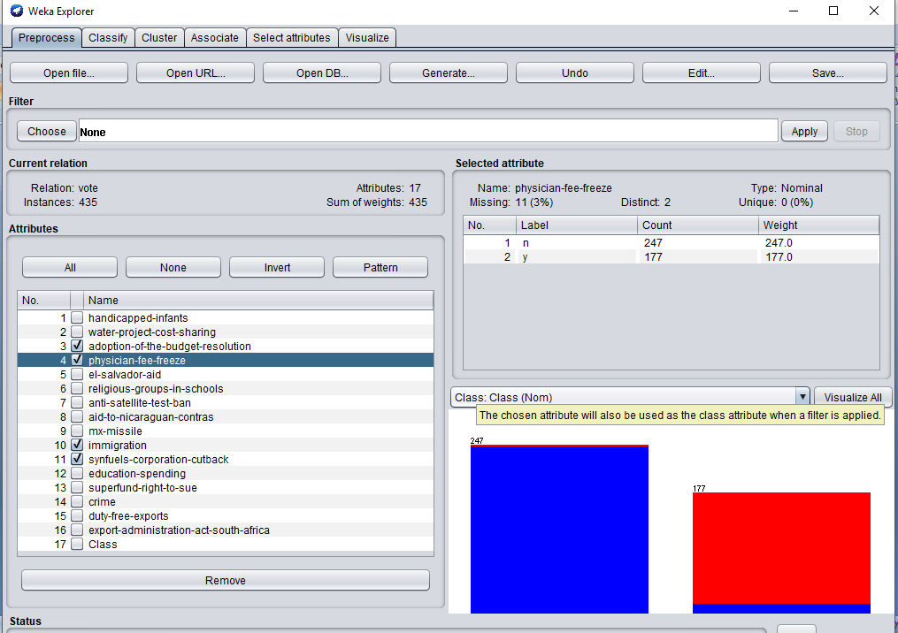

**SCAN 3:::**

SELECT ATTRIBUTES:::::

=== Run information ===

Evaluator: **weka.attributeSelection.PrincipalComponents -R 0.95 -A 5**

**Search: weka.attributeSelection.Ranker -T -1.7976931348623157E308 -N -1**

**Relation: vote**

**Instances: 435**

**Attributes: 17**

**handicapped-infants**

**water-project-cost-sharing**

**adoption-of-the-budget-resolution**

**physician-fee-freeze**

**el-salvador-aid**

**religious-groups-in-schools**

**anti-satellite-test-ban**

**aid-to-nicaraguan-contras**

**mx-missile**

**immigration**

**synfuels-corporation-cutback**

**education-spending**

**superfund-right-to-sue**

**crime**

**duty-free-exports**

**export-administration-act-south-africa**

**Class**

**Evaluation mode: evaluate on all training data**

**=== Attribute Selection on all input data ===**

**Search Method:**

**Attribute ranking.**

**Attribute Evaluator (unsupervised):**

**Principal Components Attribute Transformer**

**Correlation matrix**

**1 0.01 0.38 -0.4 -0.34 -0.39 0.34 0.36 0.33 -0.09 0.11 -0.39 -0.34 -0.37 0.22 0.21**

**0.01 1 -0.04 0.05 0.13 0.15 -0.18 -0.07 -0.17 -0.13 0.12 -0.03 0.23 -0.01 -0.1 -0.03**

**0.38 -0.04 1 -0.73 -0.62 -0.4 0.56 0.67 0.61 0.03 0.21 -0.63 -0.48 -0.57 0.46 0.44**

**-0.4 0.05 -0.73 1 0.72 0.44 -0.57 -0.67 -0.66 0.04 -0.29 0.68 0.56 0.63 -0.51 -0.4**

**-0.34 0.13 -0.62 0.72 1 0.62 -0.66 -0.78 -0.76 0.02 -0.15 0.59 0.62 0.68 -0.54 -0.36**

**-0.39 0.15 -0.4 0.44 0.62 1 -0.5 -0.51 -0.55 0.09 0.01 0.47 0.54 0.57 -0.43 -0.24**

**0.34 -0.18 0.56 -0.57 -0.66 -0.5 1 0.71 0.65 0.04 0.04 -0.52 -0.54 -0.49 0.45 0.44**

**0.36 -0.07 0.67 -0.67 -0.78 -0.51 0.71 1 0.73 0.03 0.12 -0.59 -0.55 -0.58 0.49 0.45**

**0.33 -0.17 0.61 -0.66 -0.76 -0.55 0.65 0.73 1 0.04 0.06 -0.57 -0.51 -0.54 0.46 0.38**

**-0.09 -0.13 0.03 0.04 0.02 0.09 0.04 0.03 0.04 1 -0.04 0.04 0.05 0.11 -0.04 0.06**

**0.11 0.12 0.21 -0.29 -0.15 0.01 0.04 0.12 0.06 -0.04 1 -0.18 -0.1 -0.13 0.18 0.07**

**-0.39 -0.03 -0.63 0.68 0.59 0.47 -0.52 -0.59 -0.57 0.04 -0.18 1 0.52 0.57 -0.46 -0.33**

**-0.34 0.23 -0.48 0.56 0.62 0.54 -0.54 -0.55 -0.51 0.05 -0.1 0.52 1 0.54 -0.46 -0.33**

**-0.37 -0.01 -0.57 0.63 0.68 0.57 -0.49 -0.58 -0.54 0.11 -0.13 0.57 0.54 1 -0.52 -0.3**

**0.22 -0.1 0.46 -0.51 -0.54 -0.43 0.45 0.49 0.46 -0.04 0.18 -0.46 -0.46 -0.52 1 0.27**

**0.21 -0.03 0.44 -0.4 -0.36 -0.24 0.44 0.45 0.38 0.06 0.07 -0.33 -0.33 -0.3 0.27 1**

**eigenvalue proportion cumulative**

**7.27336 0.45458 0.45458 0.325el-salvador-aid=y-0.315aid-to-nicaraguan-contras=y+0.312physician-fee-freeze=y-0.303mx-missile=y-0.294adoption-of-the-budget-resolution=y...**

**1.35652 0.08478 0.53937 -0.62water-project-cost-sharing=y-0.506synfuels-corporation-cutback=y+0.39 immigration=y+0.195anti-satellite-test-ban=y+0.167education-spending=y...**

**1.11955 0.06997 0.60934 -0.664immigration=y-0.37religious-groups-in-schools=y-0.359synfuels-corporation-cutback=y-0.334export-administration-act-south-africa=y-0.208adoption-of-the-budget-resolution=y...**

**0.91348 0.05709 0.66643 -0.601synfuels-corporation-cutback=y+0.524water-project-cost-sharing=y+0.373export-administration-act-south-africa=y-0.307duty-free-exports=y+0.202handicapped-infants=y...**

**0.79183 0.04949 0.71592 -0.832handicapped-infants=y+0.318duty-free-exports=y+0.239water-project-cost-sharing=y-0.216immigration=y-0.188synfuels-corporation-cutback=y...**

**0.76132 0.04758 0.7635 0.659export-administration-act-south-africa=y-0.54immigration=y-0.323water-project-cost-sharing=y+0.206crime=y+0.193religious-groups-in-schools=y...**

**0.61187 0.03824 0.80175 -0.512duty-free-exports=y-0.431export-administration-act-south-africa=y+0.328mx-missile=y+0.268religious-groups-in-schools=y-0.242immigration=y...**

**0.54787 0.03424 0.83599 -0.405religious-groups-in-schools=y+0.399synfuels-corporation-cutback=y+0.399education-spending=y-0.355adoption-of-the-budget-resolution=y-0.307duty-free-exports=y...**

**0.50734 0.03171 0.8677 -0.584duty-free-exports=y-0.556superfund-right-to-sue=y-0.32handicapped-infants=y-0.252education-spending=y-0.214anti-satellite-test-ban=y...**

**0.44157 0.0276 0.89529 0.524superfund-right-to-sue=y-0.458anti-satellite-test-ban=y-0.442crime=y-0.276religious-groups-in-schools=y-0.233water-project-cost-sharing=y...**

**0.39815 0.02488 0.92018 -0.619education-spending=y-0.49religious-groups-in-schools=y+0.431crime=y+0.276superfund-right-to-sue=y+0.159el-salvador-aid=y...**

**0.33086 0.02068 0.94086 0.632anti-satellite-test-ban=y-0.457mx-missile=y-0.422crime=y+0.274superfund-right-to-sue=y+0.188el-salvador-aid=y...**

**0.30531 0.01908 0.95994 0.727adoption-of-the-budget-resolution=y+0.365education-spending=y-0.342religious-groups-in-schools=y+0.302crime=y-0.179mx-missile=y...**

**Eigenvectors**

**V1 V2 V3 V4 V5 V6 V7 V8 V9 V10 V11 V12 V13**

**-0.1861 -0.1671 0.2071 0.2015 -0.8322 -0.0379 -0.0998 -0.0677 -0.3201 -0.0289 -0.1492 -0.0962 -0.0768 handicapped-infants=y**

**0.0481 -0.6202 -0.0933 0.5241 0.2388 -0.3225 -0.1493 0.2106 0.0316 -0.2326 -0.0572 -0.1151 0.1174 water-project-cost-sharing=y**

**-0.2936 -0.1006 -0.2085 0.0646 -0.0281 0.0495 0.2267 -0.3552 0.0404 0.21 -0.0447 0.1157 0.7268 adoption-of-the-budget-resolution=y**

**0.3123 0.1534 0.1222 0.0812 0.001 -0.0102 -0.207 0.2375 -0.1033 -0.1058 0.0979 0.1424 0.0925 physician-fee-freeze=y**

**0.325 -0.0598 -0.0342 0.057 -0.1466 0.1051 -0.1388 -0.2493 0.0074 -0.0814 0.1594 0.1877 0.1535 el-salvador-aid=y**

**0.2551 -0.134 -0.37 -0.0095 0.061 0.1925 0.2679 -0.4055 -0.1198 -0.2757 -0.4901 -0.0362 -0.3423 religious-groups-in-schools=y**

**-0.2877 0.1946 -0.0461 0.1238 0.0236 0.1286 0.124 0.2339 -0.2143 -0.4584 -0.0023 0.6325 -0.0086 anti-satellite-test-ban=y**

**-0.3154 0.0518 -0.1059 0.1255 0.0972 0.0023 0.2183 0.1912 -0.1548 -0.1151 -0.1438 -0.0287 0.0531 aid-to-nicaraguan-contras=y**

**-0.3029 0.1485 -0.0367 0.0632 0.0945 -0.0707 0.3278 0.1769 -0.18 0.1139 0.0999 -0.4572 -0.1786 mx-missile=y**

**0.0101 0.3897 -0.664 0.0236 -0.216 -0.5399 -0.2416 0.0292 0.0796 0.0101 -0.0277 0.0068 -0.0148 immigration=y**

**-0.0718 -0.5062 -0.359 -0.6011 -0.1877 0.1379 -0.0058 0.3995 0.0117 0.0239 0.1089 0.0824 -0.0128 synfuels-corporation-cutback=y**

**0.2842 0.1674 0.0283 -0.0616 0.0329 0.1405 -0.0888 0.399 -0.2522 0.1924 -0.619 -0.1215 0.3653 education-spending=y**

**0.2701 -0.1141 -0.1595 0.1905 0.074 -0.081 0.2392 0.0075 -0.5556 0.5242 0.276 0.2744 -0.1486 superfund-right-to-sue=y**

**0.2849 0.1266 -0.1683 0.0129 -0.122 0.2055 0.2016 0.0495 -0.2054 -0.4422 0.431 -0.4218 0.3017 crime=y**

**-0.2415 -0.0385 0.0343 -0.3067 0.3182 -0.0963 -0.5119 -0.3067 -0.5838 -0.1418 0.0322 -0.1148 0.0564 duty-free-exports=y**

**-0.1902 0.0536 -0.3344 0.3733 0.0308 0.6588 -0.4311 0.0564 0.0764 0.2066 0.0884 -0.0973 -0.1337 export-administration-act-south-africa=y**

**Ranked attributes:**

**0.5454 1 0.325el-salvador-aid=y-0.315aid-to-nicaraguan-contras=y+0.312physician-fee-freeze=y-0.303mx-missile=y-0.294adoption-of-the-budget-resolution=y...**

**0.4606 2 -0.62water-project-cost-sharing=y-0.506synfuels-corporation-cutback=y+0.39 immigration=y+0.195anti-satellite-test-ban=y+0.167education-spending=y...**

**0.3907 3 -0.664immigration=y-0.37religious-groups-in-schools=y-0.359synfuels-corporation-cutback=y-0.334export-administration-act-south-africa=y-0.208adoption-of-the-budget-resolution=y...**

**0.3336 4 -0.601synfuels-corporation-cutback=y+0.524water-project-cost-sharing=y+0.373export-administration-act-south-africa=y-0.307duty-free-exports=y+0.202handicapped-infants=y...**

**0.2841 5 -0.832handicapped-infants=y+0.318duty-free-exports=y+0.239water-project-cost-sharing=y-0.216immigration=y-0.188synfuels-corporation-cutback=y...**

**0.2365 6 0.659export-administration-act-south-africa=y-0.54immigration=y-0.323water-project-cost-sharing=y+0.206crime=y+0.193religious-groups-in-schools=y...**

**0.1983 7 -0.512duty-free-exports=y-0.431export-administration-act-south-africa=y+0.328mx-missile=y+0.268religious-groups-in-schools=y-0.242immigration=y...**

**0.164 8 -0.405religious-groups-in-schools=y+0.399synfuels-corporation-cutback=y+0.399education-spending=y-0.355adoption-of-the-budget-resolution=y-0.307duty-free-exports=y...**

**0.1323 9 -0.584duty-free-exports=y-0.556superfund-right-to-sue=y-0.32handicapped-infants=y-0.252education-spending=y-0.214anti-satellite-test-ban=y...**

**0.1047 10 0.524superfund-right-to-sue=y-0.458anti-satellite-test-ban=y-0.442crime=y-0.276religious-groups-in-schools=y-0.233water-project-cost-sharing=y...**

**0.0798 11 -0.619education-spending=y-0.49religious-groups-in-schools=y+0.431crime=y+0.276superfund-right-to-sue=y+0.159el-salvador-aid=y...**

**0.0591 12 0.632anti-satellite-test-ban=y-0.457mx-missile=y-0.422crime=y+0.274superfund-right-to-sue=y+0.188el-salvador-aid=y...**

**0.0401 13 0.727adoption-of-the-budget-resolution=y+0.365education-spending=y-0.342religious-groups-in-schools=y+0.302crime=y-0.179mx-missile=y...**

**Selected attributes: 1,2,3,4,5,6,7,8,9,10,11,12,13 : 13**

**CLASSIFY:::::**

**=== Run information ===**

**Scheme: weka.classifiers.trees.HoeffdingTree -L 2 -S 1 -E 1.0E-7 -H 0.05 -M 0.01 -G 200.0 -N 0.0**

**Relation: vote**

**Instances: 435**

**Attributes: 17**

**handicapped-infants**

**water-project-cost-sharing**

**adoption-of-the-budget-resolution**

**physician-fee-freeze**

**el-salvador-aid**

**religious-groups-in-schools**

**anti-satellite-test-ban**

**aid-to-nicaraguan-contras**

**mx-missile**

**immigration**

**synfuels-corporation-cutback**

**education-spending**

**superfund-right-to-sue**

**crime**

**duty-free-exports**

**export-administration-act-south-africa**

**Class**

**Test mode: 25-fold cross-validation**

**=== Classifier model (full training set) ===**

**physician-fee-freeze = n: democrat (246.000) NB1 NB adaptive1**

**physician-fee-freeze = y: republican (164.000) NB2 NB adaptive2**

**Time taken to build model: 0.05 seconds**

**=== Stratified cross-validation ===**

**=== Summary ===**

***Correctly Classified Instances 416 95.6322 %***

***Incorrectly Classified Instances 19 4.3678 %***

**Kappa statistic 0.9088**

**Mean absolute error 0.0832**

**Root mean squared error 0.2013**

**Relative absolute error 17.5441 %**

**Root relative squared error 41.3465 %**

**Total Number of Instances 435**

**=== Detailed Accuracy By Class ===**

**TP Rate FP Rate Precision Recall F-Measure MCC ROC Area PRC Area Class**

**0.948 0.030 0.981 0.948 0.964 0.910 0.947 0.961 democrat**

**0.970 0.052 0.921 0.970 0.945 0.910 0.947 0.871 republican**

**Weighted Avg. 0.956 0.039 0.958 0.956 0.957 0.910 0.947 0.926**

**=== Confusion Matrix ===**

**a b <-- classified as**

**253 14 | a = democrat**

**5 163 | b = republican**

**AFTER REMOVING THE ABOVE ATTRIBUTES:::::**

**=== Run information ===**

**Evaluator: weka.attributeSelection.ClassifierAttributeEval -execution-slots 1 -B weka.classifiers.rules.ZeroR -F 5 -T 0.01 -R 1 -E DEFAULT --**

**Search: weka.attributeSelection.Ranker -T -1.7976931348623157E308 -N -1**

**Relation: vote-weka.filters.unsupervised.attribute.Remove-R3-4,10-11**

**Instances: 435**

**Attributes: 13**

**handicapped-infants**

**water-project-cost-sharing**

**el-salvador-aid**

**religious-groups-in-schools**

**anti-satellite-test-ban**

**aid-to-nicaraguan-contras**

**mx-missile**

**education-spending**

**superfund-right-to-sue**

**crime**

**duty-free-exports**

**export-administration-act-south-africa**

**Class**

**Evaluation mode: evaluate on all training data**

**=== Attribute Selection on all input data ===**

**Search Method:**

**Attribute ranking.**

**Attribute Evaluator (supervised, Class (nominal): 13 Class):**

**Classifier feature evaluator**

**Using Wrapper Subset Evaluator**

**Learning scheme: weka.classifiers.rules.ZeroR**

**Scheme options:**

**Subset evaluation: classification accuracy**

**Number of folds for accuracy estimation: 5**

**Ranked attributes:**

**0 12 export-administration-act-south-africa**

**0 11 duty-free-exports**

**0 4 religious-groups-in-schools**

**0 3 el-salvador-aid**

**0 2 water-project-cost-sharing**

**0 5 anti-satellite-test-ban**

**0 6 aid-to-nicaraguan-contras**

**0 7 mx-missile**

**0 10 crime**

**0 9 superfund-right-to-sue**

**0 8 education-spending**

**0 1 handicapped-infants**

**Selected attributes: 12,11,4,3,2,5,6,7,10,9,8,1 : 12**

**CLASSIFY ::::**

**=== Run information ===**

**Scheme: weka.classifiers.trees.J48 -C 0.25 -M 2**

**Relation: vote-weka.filters.unsupervised.attribute.Remove-R3-4,10-11**

**Instances: 435**

**Attributes: 13**

**handicapped-infants**

**water-project-cost-sharing**

**el-salvador-aid**

**religious-groups-in-schools**

**anti-satellite-test-ban**

**aid-to-nicaraguan-contras**

**mx-missile**

**education-spending**

**superfund-right-to-sue**

**crime**

**duty-free-exports**

**export-administration-act-south-africa**

**Class**

**Test mode: 25-fold cross-validation**

**=== Classifier model (full training set) ===**

**J48 pruned tree**

**------------------**

**el-salvador-aid = n: democrat (215.43/9.49)**

**el-salvador-aid = y**

**| education-spending = n**

**| | crime = n: democrat (12.79/1.31)**

**| | crime = y**

**| | | religious-groups-in-schools = n: republican (4.39/1.11)**

**| | | religious-groups-in-schools = y**

**| | | | mx-missile = n**

**| | | | | anti-satellite-test-ban = n**

**| | | | | | aid-to-nicaraguan-contras = n**

**| | | | | | | duty-free-exports = n**

**| | | | | | | | export-administration-act-south-africa = n: democrat (6.38/1.32)**

**| | | | | | | | export-administration-act-south-africa = y: republican (9.05/2.73)**

**| | | | | | | duty-free-exports = y: democrat (3.57/0.28)**

**| | | | | | aid-to-nicaraguan-contras = y: democrat (4.0/0.09)**

**| | | | | anti-satellite-test-ban = y**

**| | | | | | handicapped-infants = n: republican (3.19)**

**| | | | | | handicapped-infants = y**

**| | | | | | | aid-to-nicaraguan-contras = n: democrat (3.01/0.01)**

**| | | | | | | aid-to-nicaraguan-contras = y: republican (2.26)**

**| | | | mx-missile = y: democrat (8.15/0.04)**

**| education-spending = y**

**| | duty-free-exports = n: republican (147.38/16.58)**

**| | duty-free-exports = y**

**| | | water-project-cost-sharing = n: republican (9.69/1.5)**

**| | | water-project-cost-sharing = y: democrat (5.69/1.43)**

**Number of Leaves : 14**

**Size of the tree : 27**

**Time taken to build model: 0 seconds**

**=== Stratified cross-validation ===**

**=== Summary ===**

**Correctly Classified Instances 382 87.8161 %**

**Incorrectly Classified Instances 53 12.1839 %**

**Kappa statistic 0.7439**

**Mean absolute error 0.1816**

**Root mean squared error 0.31**

**Relative absolute error 38.2959 %**

**Root relative squared error 63.671 %**

**Total Number of Instances 435**

**=== Detailed Accuracy By Class ===**

**TP Rate FP Rate Precision Recall F-Measure MCC ROC Area PRC Area Class**

**0.895 0.149 0.905 0.895 0.900 0.744 0.897 0.907 democrat**

**0.851 0.105 0.836 0.851 0.844 0.744 0.897 0.796 republican**

**Weighted Avg. 0.878 0.132 0.879 0.878 0.878 0.744 0.897 0.864**

**=== Confusion Matrix ===**

**a b <-- classified as**

**239 28 | a = democrat**

**25 143 | b = republican**

**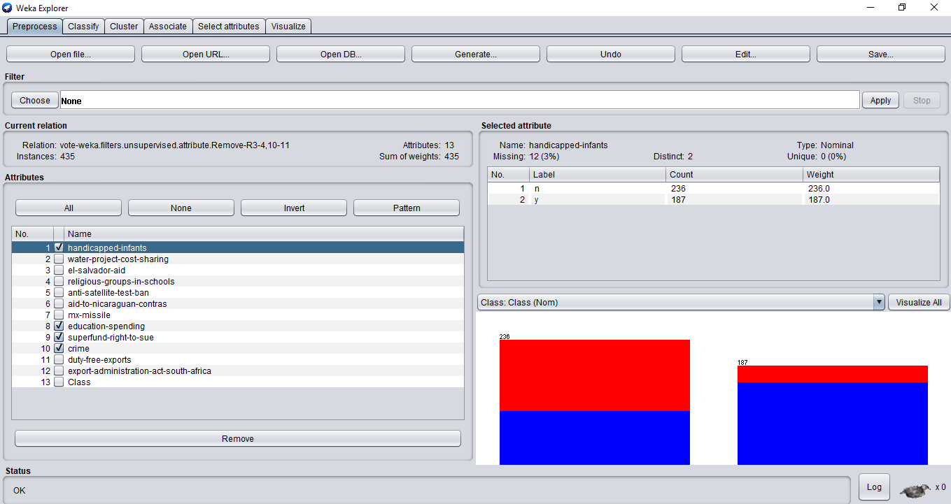**

**Source:**

Origin:   
  
Congressional Quarterly Almanac, 98th Congress, 2nd session 1984, Volume XL: Congressional Quarterly Inc. Washington, D.C., 1985.   
  
Donor:   
  
Jeff Schlimmer (Jeffrey.Schlimmer **'@'** a.gp.cs.cmu.edu)

BY:: ASHISH RANA

GRAPHIC ERA DEEMED UNIVERSITY